**ONLINE CAKE ORDERING SYSTEM**

Sowmya Para Akhil Pendem Satya.A.P.K.R.Padala Sahithi Papireddy Sandhyarani Cheelamanthula   
 *700692587 700694030 700691883 700697117 700700262*

*Dr. Mahmoud Yousef   
 Project Advisor*

*University of Central Missouri*

May 5th, 2020

***Abstract-* This is a Final report document. Cake Ordering system is a system which helps in lowering manual intervention in the process of ordering. This will also help the employees to manage workload and benefit the customers due to the database/ information system.**

I. INTRODUCTION

This Project demonstrates the benefits of having Online Cake Ordering system than Ordering In person or through Telephone.

II. REQUIREMENT ANALYSIS

Requirements are considered by understanding the current system and problems facing with the existing system. In the Current system i.e.

Ordering a cake via in person or Telephone, there could be a chance of getting errors due to technical or language constraints. It is also lengthy and tedious. More human power is needed to take orders, process and inform customers regarding the order.

Our Proposal is to create an application for Ordering Cake Online which makes the error free orders and helps to decrease the workload of the employees. A website which will guide the user to browse and order a cake online also saves a lot of time. With the requirements ,we build a basic business model which is shown below.

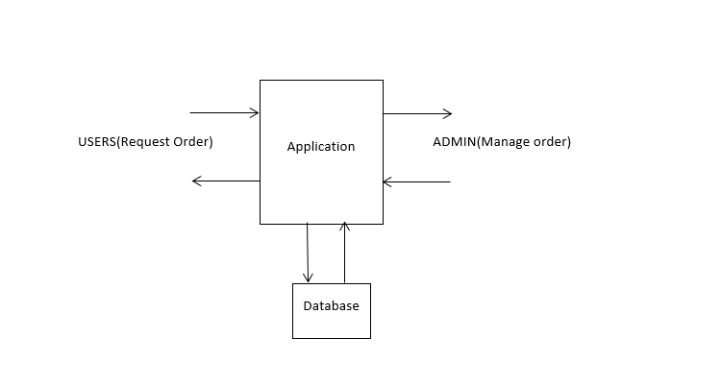

III. DESIGN/MODULE DESCRIPTION   
*Customer*:

A Database is required to store the customer data that is their name, full name, email address, phone number, date of birth. These details are stored in the database and all the customer details are viewed to admin. Admin provides all the cake varieties to the customer so that the customer can book the cake. The operations involved in this module are Create required HTML Pages, register customer details, Apply Style sheets, Perform Validations, Prescript the cake’s to customers, register customer details and Integrating with other modules.

*Booking*:

This Module deals about the booking of a cake from the cake booking system. Customer can book cake from the menu. The menu includes different types of cakes . If the customer wants to cancel cake, he can cancel it by providing the Customer name and phone number which are used while ordering a cake. The operations involved in this module are Create required html Pages, Apply Style sheets, Perform Validations, booking details, Cancellation details, updating details and Integrating with other modules.

*Product Function:*

The Online Cake Order System application would have the following basic functions:

1. *Web Ordering System Module:*

This module provides the functionality for customers to place their order and supply necessary details. Users of the system, namely customers, must be provided the following functionality:

• Create an account.

• Log into the system.

• Navigate menu.

• Select an item from the menu.

• Review their current order.

• Provide payment details.

• Place an order.

• Check out

• Receive confirmation in the form of an order number.

• View order placed.

• Cancel order.

1. *System Module:*

This module provides functionality for the power user-Administrator only. It will not be available to any other users of the system like Bakery Employees or Customers. Using a graphical interface, it will allow an Admin to manage the menu that is displayed to users of the web ordering system:

• Add/update/delete category to/from the menu.

• Add /update/delete cake to/from the menu.

• Update price for a given food item.

• Update additional information (description, photo, etc.) for a given food item.

By using the above speciation’s which we finalized in the design phase ,implemented use case diagram ,Activity diagram, class diagram and Sequence diagrams representing the functionalities and paths to be implemented which will be helpful while implementing the actual product.

Activity diagrams represent the flow of use cases .From these classes can be derived and the Class diagram is represented. Sequence diagram represents the interactions between the classes.

*Use Case Diagram:*

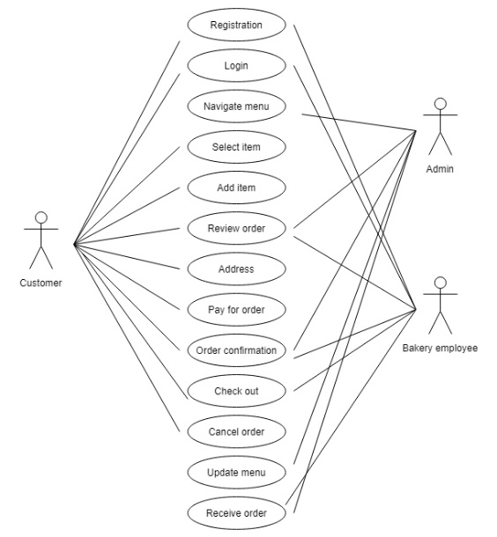

*Activity diagram*

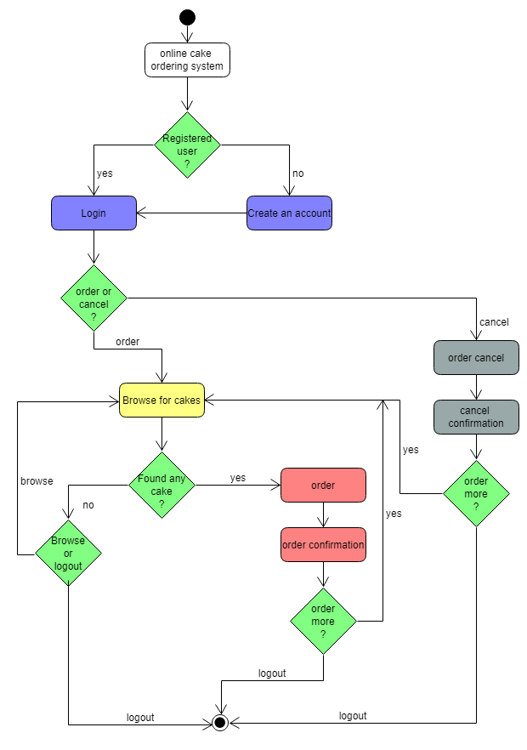

*Class Diagram:*

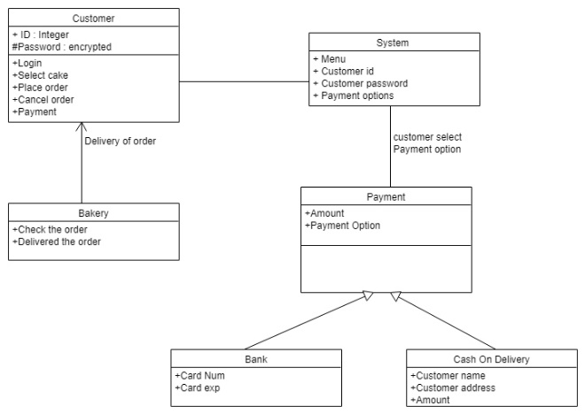

*Sequence diagram*

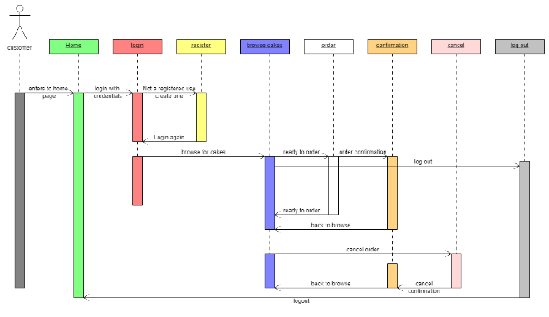

IV. HARDWARE/SOFTWARE INFRASTRUCTURE

*Hardware:*

* Intel I5 Processor
* Ram 16GB
* Rom 250GB

*Software:*

* NetBeans IDE 8.0.2
* Java DB
* Drivers: Java Runtime Environment
* Web Browser: IE 10 or above, Mozilla FF 31 and above or Google Chrome
* Operating System: Windows (Vista/7 or above) / Mac

V. IMPLEMENTATION

This module design needs several web pages implementation which includes Login, Registration, Ordering, Cancellation pages implemented using HTML language.

The homepage displays the different flavors of cakes and this is the page where customer can login, signup into website and order a cake or cancel order. This page is especially designed to only view the products ,for ordering ,people should signup and login into the website.

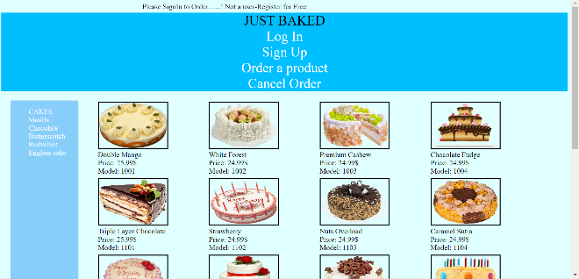

The Sign-up page seeks the customer information all the fields required to get the information from customer are created in this page. After signing up with the site the customer will get the user ID and password.

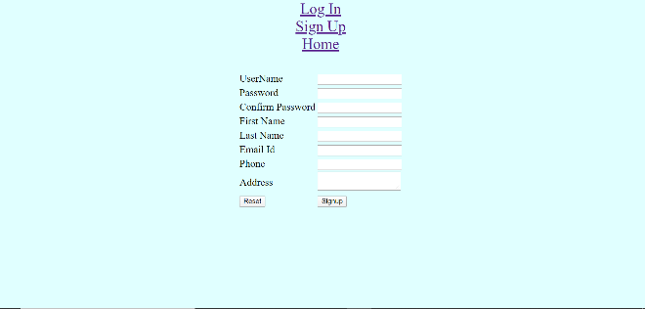

Once Signup process is done , A button “Please login ” will be seen to redirect to Login page.



The Login page directs customer to the Home page where customer could see the cakes and different flavors list, and it will direct to Order and Cancel pages.



The order page displays the name of the product and its unique id in dropdowns giving a provision to select the required cake, customer’s details including their address and type of payment details like Online, Cash on delivery (COD).

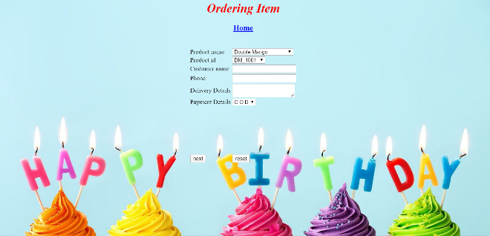

Once Order is done , Booking ID is generated.



Users also should be able to cancel the orders with the Phone number and Customer name given while booking the order.

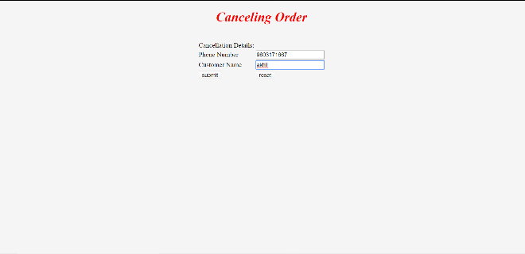

If the given details are valid ,given order should get cancelled and a cancellation ID will be generated.

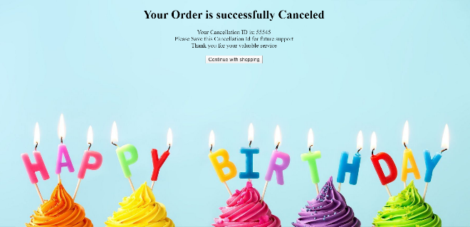

We used phpMyAdmin here for MySQL to create tables and store values of Registration and order details of a customer.

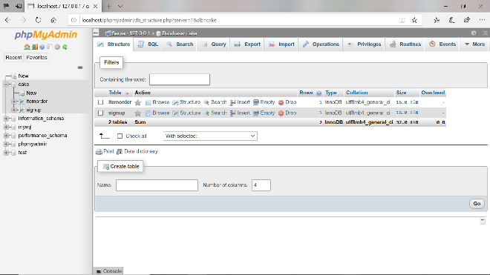

VI. TESTING

In our Project ,we have performed testing by designing cases Using the “**Test to Specification**s” approach (Also called as Black-box testing).  
  
Also we have divided the test cases into two parts in a way that resembles Positive and Negative testing i.e. Test cases which test the functionality using valid data is called **Positive Testing** and the test cases which are designed to Break the Functionality with invalid data is called **Negative Testing**.

Below are the test cases which we used for testing the Project.  
  
*Positive Test cases* :

Sign up Page :

1.Verifying the Sign-up button by providing the data in the Fields

Login Page :

1.Verifying the Functionality of Login button with Valid Credentials.

Order Page :

1.Placing an order by providing the required details.  
  
Cancellation Page :

1.Cancel the order by using Valid Phone number and Customer Name.

*Negative Test cases* :

Sign up Page :

1.Verifying the Sign-up button without providing the data in the Fields

Login Page :

1.Verifying the Functionality of Login button with Invalid Credentials.

2.Verifying the Functionality of Login button without giving any data in the fields.

Order Page :

1.Placing an order without providing the required details.  
  
Cancellation Page :

1.Cancel the order by using In Valid Phone number or Customer Name.

VII. TEST OUTPUT

**Actual results** for all the test cases are **same** as **Expected results** .Below are the results seen for every test case written.

*Positive Test cases :*

*Sign up Page :*

*1.Verifying the Sign-up button by providing the data in the Fields –* Able to see the Login got created and the details are stored in the Database.

*Login Page :*

*1.Verifying the Functionality of Login button with Valid Credentials. –* Able to Login and see the home page.

*Order Page :*

*1.Placing an order by providing the required details.-* Order got placed and an Order ID got generated and stored in the Database. *Cancellation Page :*

*1.Cancel the order by using Valid Phone number and Customer Name-* Able to Cancel the Order and generate Cancellation ID

*Negative Test cases :*

*Sign up Page :*

*1.Verifying the Sign-up button without providing the data in the Fields –* No action is seen as the data is not filled in the fields .

*Login Page :*

*1.Verifying the Functionality of Login button with Invalid Credentials.-*  Not giving provision to go to home page as the credentials are invalid

*2.Verifying the Functionality of Login button without giving any data in the fields. –* No action is seen as the data is not filled in the fields .

*Order Page :*

*1.Placing an order without providing the required details. -* No action is seen as the data is not filled in the fields .

*Cancellation Page :*

*1.Cancel the order by using In Valid Phone number or Customer Name. –* Error message is seen stating the Details are invalid.

VIII. CONCLUSION

With the workflow used i.e. RADIT(Requirement, analysis ,design, implementation, testing ) for developing our project helped to complete the project within timeline as less prone to errors. But errors found while testing phase which lead to changing in the requirements are tough to handle